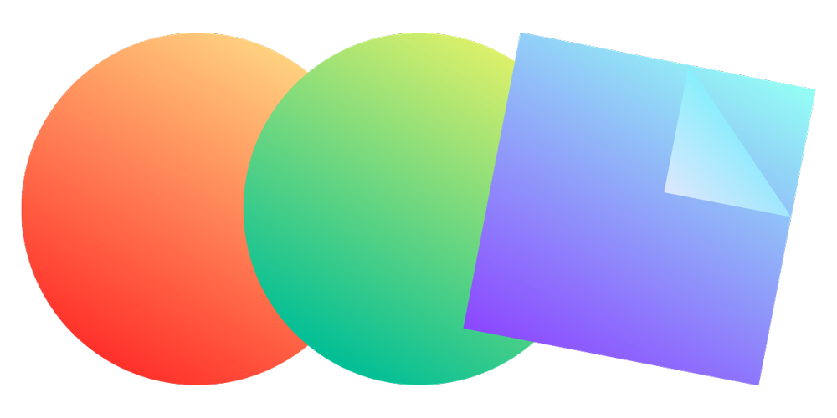

Project A. Generative Creatures

**Interaction Day: October 11  
Presentation: Due October 24**

**Documentation: Due October 26**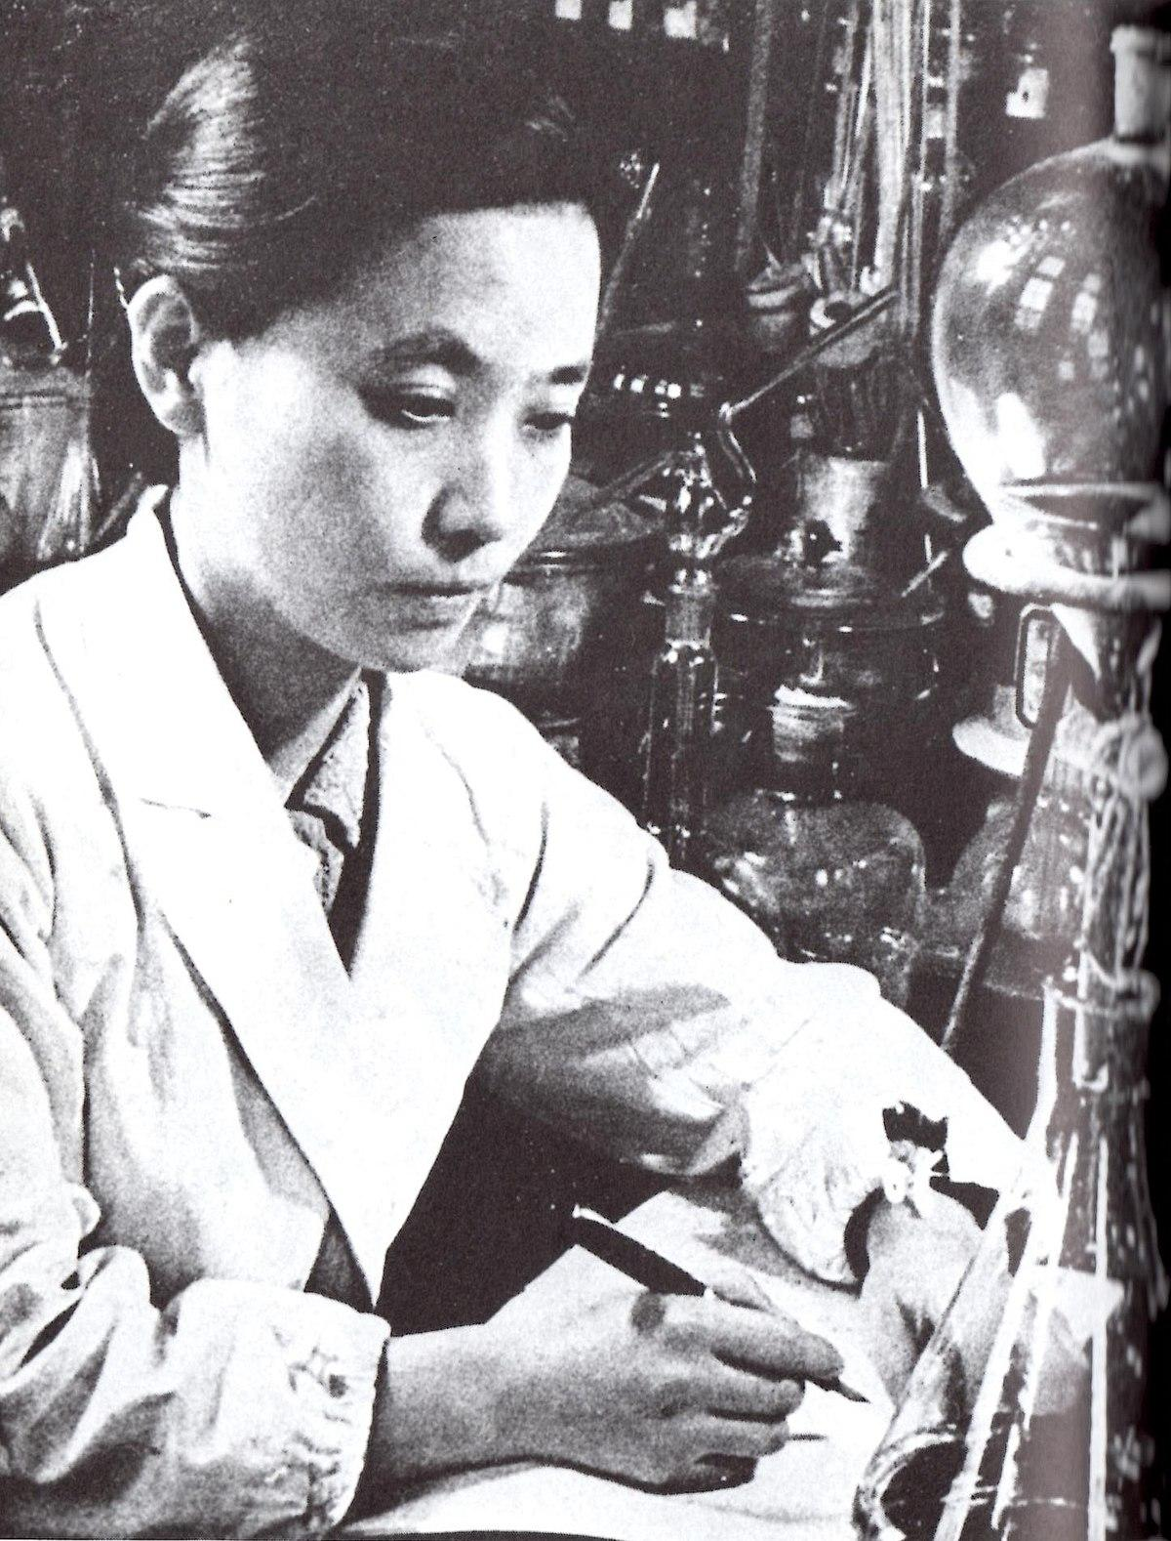

**Introduction.**   
You are a scientist and your quest is **the discovery of new forms of life** in your laboratory.

Your process begins with a single unit/bacteria/creature which – placed on your canvas – comes to life and into motion.

In the next phase, you are using all the equipment at your disposal to animate this creature and **observe as it mutates and develops**. Your expertise is to experiment with its **motion**, increasing its complexity gradually. Its **shape**, too, emerges and it starts to perform reactions to its spectators’ **interactions**. 

A key discovery is that this creature, whenever growing anew, seems to never look or move exactly the same as prior. It is as if **some of its features generate with a degree of randomness!**  
  
The process of crafting this form of life takes care and takes time; as you do it, your responsibility is to observe and discover the creature's character and **its story – why does it move and look the way it does?** What is its natural habitat, does it eat and if yes, what? **Extend a detailed description** of the creature and present both to an esteemed audience of other scientists soon!

**The assignment**

You are asked to make a **generative visual** that evolves based on the conditions you design. The idea of breeding a new form of life *can* be the starting point of your ideation, but does not have to be literal. The visual you create shall **not remain static** – it never looks exactly the same way twice (it’s generative) and it **responds visually to our interaction** with it.

| Dimension Requirements for your sketch: 800x500pixel createCanvas(800, 500); |
| --- |

**What your process might look like?**  
Utilizing the coding concepts we have covered so far, draw a primitive shape (week 1) and experiment with different motions (week 3). As you advance, defining how this living being moves, implement meaningful interactions (week 2, i.e. keyboard, mouse) to create reactions or even behaviors. Interactions can be **simple**, but should be **meaningful** within the story you are creating.

Increase complexity of your creature using loops and arrays (week 4 & 5); these tools also suit themselves well for achieving generative outcomes. Structure your code with functions (week 5).

From the start, your experiments with code should influence the narrative you create for your creature, and vice versa. The **storytelling is an integral part of this project**. Why does this living being take a specific shape, why does it move and behave the way it does? You may think, for example, about its story, natural habitat, diet, species relatives or predators (find inspiration in the links below).

**Finishing touches**  
In week 6 (one week before the project presentations), you will be introduced to HTML and CSS. In this project, you are **not expected to fully apply** these particular learnings (you don’t have to code html and css). Instead, you will be given various **HTML templates** which you must use, and you will need to publish the project to the web (also covered in week 6). The templates will **place your sketch into a context** of web elements in which your narrative (information about the creature’s habitat and everything that makes it unique) should be placed. The webpage then will be part of the [*Creative Coding Lab Biodiversity Atlas*](https://cclab.work/atlas/), a collection of all creatures ever discovered (coded) by CCLab scientists (students).

A reference for this are these websites:

* <https://biodiversityla.org/species/iconic/giant-keyhole-limpet/>
* <https://biodiversityla.org/species/iconic/ca-poppy/>
* <https://biodiversityla.org/species/iconic/rockfish/>
* more: <https://biodiversityla.org/species/iconic/>

**Inspiration**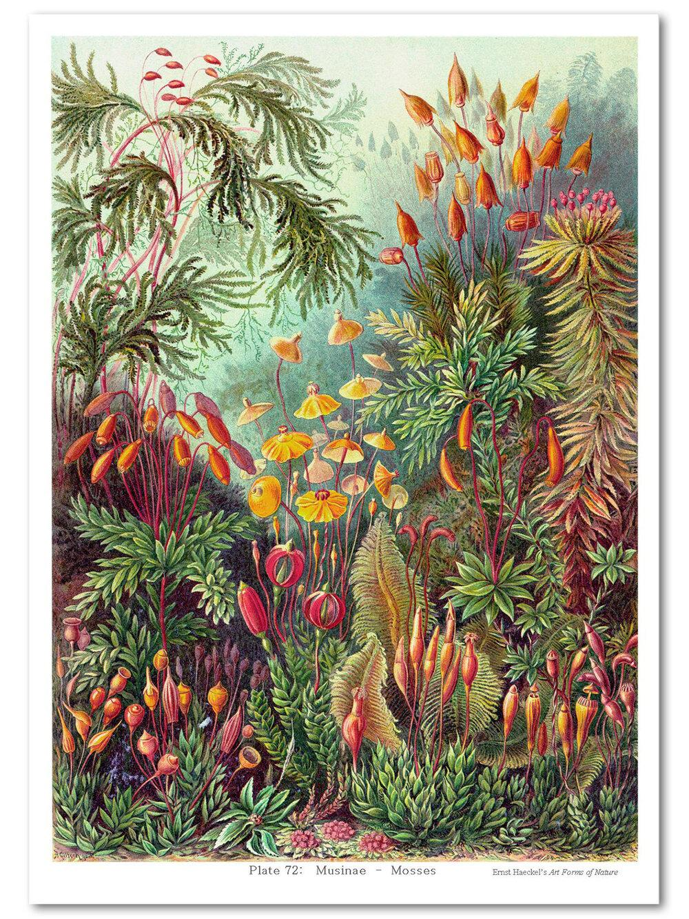

We encourage you to spend some time outside and observe nature. Observe different materials, types of motion, or a phenomenon from the real, natural world. Clouds, animals, insects, plants, and even people can all provide you with ideas. You may draw inspiration from **the sources we prepared for the** [**Artistic Inspiration Assignment**](https://docs.google.com/spreadsheets/d/1GQdHYBwMQIo48XZnryPpWCXSovbqnD8fVK2QnW-dSjU/edit?usp=sharing) in the creative process, too. Besides going outdoors to observe nature, you may find some inspiration on the [Generative Art Lecture Slides](https://docs.google.com/presentation/u/0/d/1p5fHvoqRd0qkMUYHz9OC03Z4QuRE9LGsYEuY4hn1CCQ/edit). Although this project will be completed **individually**, but may start your ideation with a partner, so your creatures could be part of a shared ecosystem.

**Deliverables**  
The project includes three parts:

**- A web page that includes a p5 sketch and is hosted on GitHub Pages**  
**-** **In-Class Presentation   
-** [**"Project Documentation"**](https://docs.google.com/document/d/1Vuh0NCqSwlTPbTc7P7jjQT4Vi0ejmj_XsRIuxmhkRHA/edit?usp=sharing) **Blog Post**

## Requirements:

* Attribute references you were inspired by.
* Credit the Creative-Commons licensed sources you used.
* It is important that your code is written by yourself and **only uses the concepts that are part of CCLab’s course materials** (e.g. you shouldn’t use vectors in your code since they were not covered). You should not use ChatGPT or other AI tools for any purpose other than idea generation. When you use any of these tools, you must include a note describing how you used them with the assignment; please also reflect on your experience with these tools.
* Please also review the [CCLab Academic Honesty Statement](https://docs.google.com/document/d/1SxstfrEtQOGeL8oa8QRKDzGCnDgACTa9YpP4IMUDeaI/edit).

## 

## Learning Outcomes

Upon completion of this project, students will be able to:

* use the fundamentals of programming;
* apply comprehensively various methods in p5.js and visualize generative and interactive animations;
* publish a p5.js sketch on the web using Github
* practice approaches to project management — scoping, project plans, project reviews, and;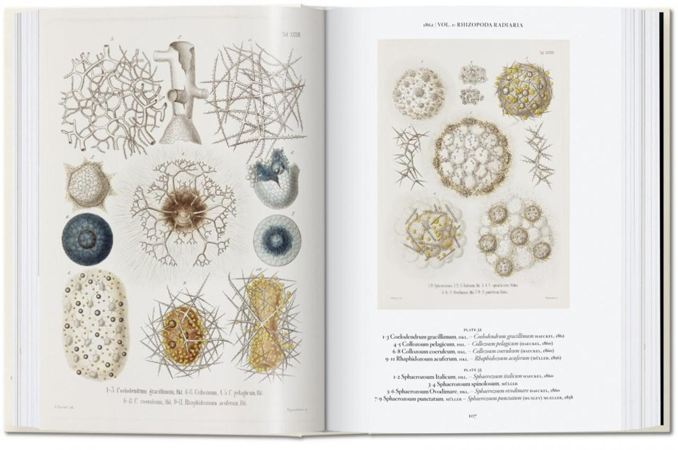
* develop and structure a larger-scale project.